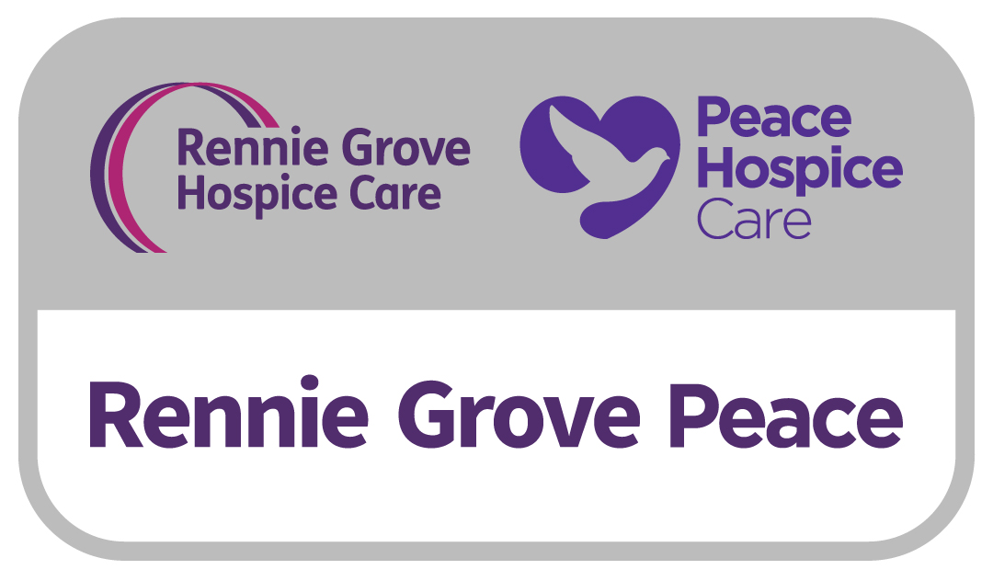

**London Bridges Walk**

**Terms & Conditions**

**General**

* The London Bridges Walk starts at The Pear Tree Cafe in Battersea Park and finishes at Potters Field next to Tower Bridge. 5-mile walk ending at Parliament Square.
* Both 5- and 10-mile walks will set off between 9.30am and 10.30am.
* All entry fees are non-refundable and non-transferrable if you choose to not to take part.
* If you have registered for London Bridges Walk and find that for any reason you are unable to take part, please let us know as soon as possible. You must not give your place to anyone else, and you must return your sponsorship form to Rennie Grove Peace Hospice Care.

**Participant entry**

* Any walker under 16 must be accompanied by a responsible parent or guardian aged 18 or older on the day.
* The London Bridges Walk is open to all ages and is priced at £15 for adults 16 years and over and £10 for children under 15 years. Early Bird registration fee is priced at £12 for adults 16 years and over and £8 for children under 15 years. Children under 5 are free.
* Early bird registration ends on Sunday 2 February 2025. Rennie Grove Peace reserves the right to change this date at any time.
* Online registration for the event will be open until midnight on Wednesday 5 March 2025.

**Health and safety**

* If you are in doubt about your health or have a medical condition that could be affected by exercise, you should obtain your doctor’s approval before participating in the London Bridges Walk.
* By taking part in the event, you understand that Rennie Grove Peace Hospice Care is not liable for your health or possessions before, during or after the event and that you participate at your own risk.
* We reserve the right to refuse entry to the event at our discretion with no refund provided, if for whatever reason we consider a person unfit to take part.

**Use of your information**

* You confirm that you have permission from all members of your team (or their parent/legal guardian if they are under 18) to provide entry information (including information of a sensitive and personal nature) and for Rennie Grove Peace to use the personal data of team members (including emergency contact details) for the purposes of administering this event.
* Emergency contact and medical details will be deleted after the event.
* Please note that by entering this event and accepting these Terms and Conditions you give us permission to contact you for the purposes of communicating about this event. This permission will override any previous instruction you may have given us to “unsubscribe” your details from our database.
* We will add your contact details to our database and will send you news and fundraising information by post unless you have asked us not to.
* You can update your preferences at any time by visiting the contact preference form on our website: [renniegrovepeace.org/preferences](http://www.renniegrove.org/preferences).
* Please address any questions, comments and requests regarding our data processing practices to Rennie Grove Peace Hospice Care, Rennie House, Icknield Way Industrial Estate, Tring HP23 4JX.

**Filming and photography at event**

* Rennie Grove Peace Hospice Care wishes to use photographs, video footage, or other records of this event which may include images featuring you or members of your team. By taking part, you confirm that you grant Rennie Grove Peace Hospice Care permission to use these images for any of its marketing purposes in all and any media, in their original format or edited or altered in any way which Rennie Grove Peace Hospice Care thinks appropriate, and that you do not object to the storing and use of copies of the images.

**Sponsorship money and donations**

* You are not permitted to use any of the sponsorship money you raise to pay for your place or any expenses. All sponsorship raised must be given to Rennie Grove Peace Hospice Care.
* The event is a sponsored charity fundraiser and by taking part you pledge to raise the suggested minimum donation of £120 per person. Rennie Grove Peace covers the cost of putting on this event and for this reason we do not allow people taking part to raise money for other charities. If you raise over £120 you will receive an event beanie hat. If you raise over £240 you will receive an event hoodie. Those of you who have setup a Just Giving page will receive an email once you hit these milestones. If you raise money in another way, please email us to let us know on [events@renniegrovepeace.org](mailto:events@renniegrovepeace.org).

**Changes and last-minute arrangements**

* In case of unforeseen circumstances Rennie Grove Peace Hospice Care reserves the right to cancel this event at any time. In the event of cancellation by Rennie Grove Peace Hospice Care your entry fee will be refunded.